the ncML specs group
ncML-G
and
ncML-G_{ML} Ver. 0.3.1
An extension of ncML for enabling interoperability with GIS

OVERVIEW


When netCDF meets GIS Coomunity

Editor: Stefano Nativi

January 2005

UNIDATA / UCAR
University of Florence
Italian National Research Council /IMAA

Send comments to nativi@ucar.edu ( nativi@imaa.cnr.it )

Index
Index 2
Objectives 3
Overview 3
The Abstract Model 4
From Dataset to Coverage 4
Extent information 7
Location information 7
Geometry information 7
The general content model 7
GeoDomainExtent model 8
GeoDomainLocation model 8
UnreferencedCoverage model 9
ReferencedCoverage model 9
The encoding model 9
XML Schemas 10
NcML-G_{ML} SCHEMA DOCUMENTATION 12
NcML-G_{ML} utilization scenarios 12
Interoperability scenarios 13
Use cases Motivation 14
Terms and Definitions 15
References 16

Objectives
The main object of the GIS extension model for ncML is to facilitate the interoperability between the Earth Sciences and the GIS Communities.
Such interoperability is essential to support interoperability: between the Earth Sciences Community and the Society.
The present extension introduces a set of optional elements which are useful to describe a netCDF dataset according to geo-spatial models introduced by international committee for standardization.
These elements are based on the following international standardization initiatives: OGC OpenGIS and ISO TC211.
The ncML-G expected result is to ease the import of netCDF dataset from GIS tools.
The ncML-G_{ML} schema was conceived to explicitly formalize the introduced solution to harmonize Earth Sciences and GIS data models (i.e. ncML-G). NcML-G_{ML} must consist of two parts (or views):
– a multidimesional array model for ES community realm;
– a feature/coverage model for GIS community realm;

Overview
The ncML-G specification introduces:
- An abstract model of the extension;
- A general content model of the extension;
- An XML implementation of the extension content model, resorting to GML 3.0 grammar: the ncML-G_{ML} encoding
The abstract model represents the conceptual approach used to interconnect Earth Sciences and GIS data models, achieving model interoperability.
The content model represents the objects model introduced for the extension. It implements the abstract model and it is expressed using the UML notation.
The following diagram presents the followed approach:
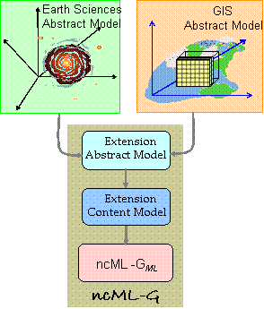
Approach for achieving ES and GIS Model Interoperability

The GML-based implementation (ncML-G_{ML}) was conceived to:
- encode Earth Sciences geographic aspects, using GML 3.0;
- use GIS Community semantics;
- facilitate as much as possible GIS systems to “import” ncML datasets.
The following schema depicts the extension encoding architecture.
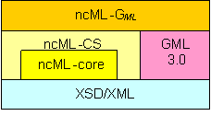
Architecture of the Extension encoding

The Abstract Model

From Dataset to Coverage
The model of Earth Sciences (ES) dataset is generally different from GIS data model. In particular, most of ES data models are based on a composite approach; besides, most of GIS data models follow a geo-relational approach.
Composite approach is characterized by a bottom-up way to organize data (i.e. from single measurement values to eventual aggregated entities made up of measurement values). On the contrary, geo-relational approach is characterized by a top-down way to organize data (i.e. from meaningful aggregation entities to their actual measurements content).
We introduced an abstract model for the GIS extension, which facilitates the interconnection between these two approaches, as far as ncML and standard Coverage models are concerned.
The following diagrams depict such scenario presenting the considered composite and geo-relational models and the introduced abstract model for the extension.
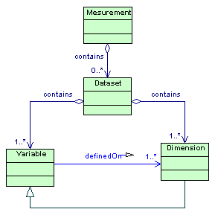
The considered Composite model
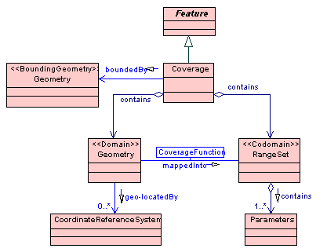
The considered Geo-relational model
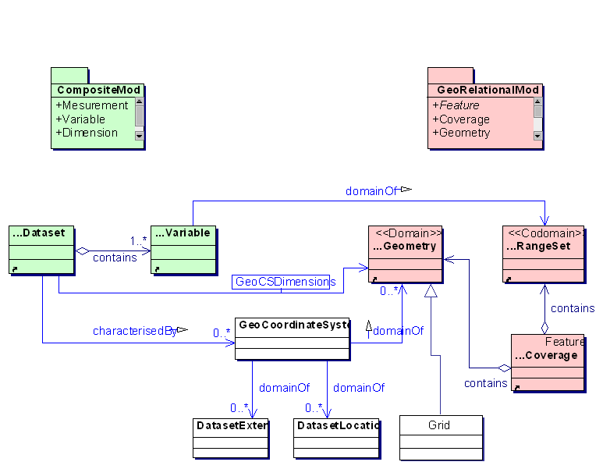
The Abstract model for achieving models interoperability
As shown in the abstract model diagram, the key concept is to define Geo-Coordinate Systems from ncML datasets. Hence, ncML-CS model is the natural starting point for GIS extension.
Referring to the abstract model diagram, there are three main useful extensions:
- To generate geo-extent information for a netCDF dataset;
- To generate geo-location information for a netCDF dataset;
- To generate one or more coverages from a netCDF dataset.
All these extensions are useful for facilitating ES and GIS systems interoperability.
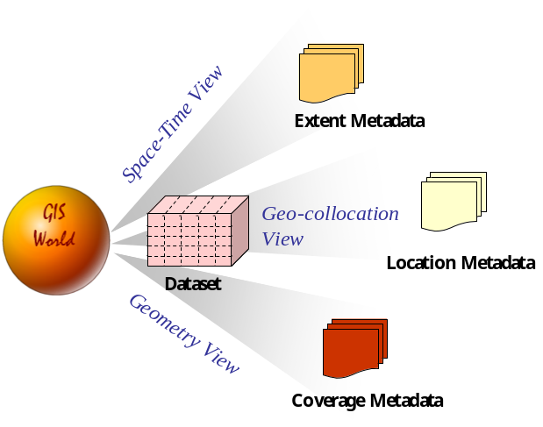
Useful Metadata for facilitate interoperability

Extent information
The extent metadata refers to the dataset spatial and temporal domain. It is useful for Online Catalogue applications, for discovering, classifying and filtering datasets.

Location information
The location metadata refers to dataset coordinate system. It is useful for GIS tools and applications to represent the dataset values on referenced maps and overly its values on geo-referenced layers (e.g. themes).

Geometry information
The geometry metadata refers to dataset inner organization of counts, for example: regular or irregular grids. It is useful for GIS tools and applications to implement topological functionalities and allow spatial queries on the dataset values.

The general content model
Starting from the introduced abstract model for the extension, a content object model was introduced. Such model considers the ncML-CS model and ISO 19123 coverage model.
The following schema depicts the main object packages.

Content model packages view
The following schema represents the extension object model which encompasses the different packages.
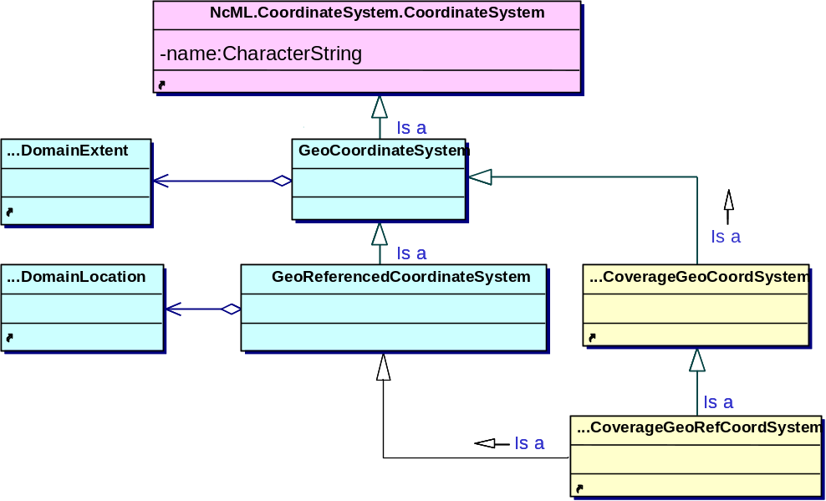
Extension object model
Referring to the schema, different colors refer to the different xml schemas the objects are encoded by.

GeoDomainExtent model

Extent Metadata object model

GeoDomainLocation model

Location Metadata object model

UnreferencedCoverage model

Coverage/Geometry Metadata object model: unreferenced case

ReferencedCoverage model

Coverage/Geometry Metadata object model: referenced case

The encoding model
The general content model was encoded into a semi-structured model (i.e. XML schema) introducing a GML-based set of elements. It is called ncML-G_{ML} semi-structured models.

XML Schemas
Two main XML schema are introduced to encode the ncML-G content model:
- geoCoordinateSystem.xsd;
Its URN is: urn:ncML:specification:schema-xsd:geoCoordinateSystem:v0.3.1
It specifies extent and location metadata for geo coordinate systems defined in ncML Dataset. It extends ncML coordinate axis information, by adding geographic metadata on their domain.
- coverageGeoCoordSystem.xsd;
Its URN is: urn:ncML:specification:schema-xsd:coverageGeoCoordSystem:v0.3.1
It specifies metadata for coverage associated with an un-referenced or referenced geo coordinate system. It extends the geoCoordinateSystem content by adding implicit geometry information which characterizes coverage (i.e. grid geometry).

The ncMLG_{ML} encoding model uses elements defined in the following GML 3.0 schemas:
- feature.xsd;
- temporal.xsd;
- coordinateReferenceSystems.xsd;
- grids.xsd;
- coverage.xsd;
The following schema shows the schemas dependencies.
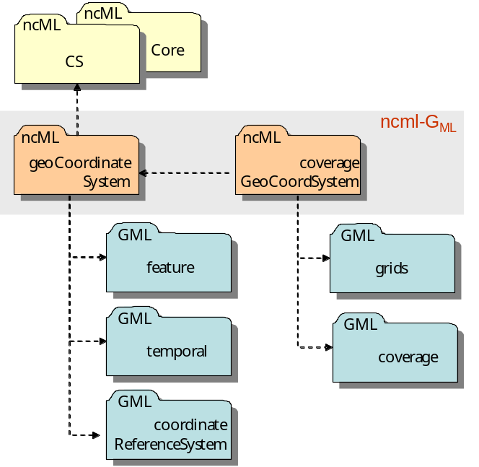
XML Schemas dependencies
As far as netCDF coverage is concerned, the root element is the "netcdfCoverages" which extends a "netcdf" element. This element contains all the variables (i.e. dimensions and measurement fields) defined in the original netCDF dataset – and modeled as sub-element of a general “netcdf” element- plus one or more "coverageGeoCoordinateSystem" elements, one for each coverage achieved starting from the original netCDF dataset.
A "coverageGeoCoordinateSystem" element contains all information required for GIS interoperability, that is: domain extent, domain location and domain geometry (i.e. grid metadata); besides, it can contain the measurement fields values, too.
The following picture depicts the dependencies between netCDF concepts and ncML main elements.
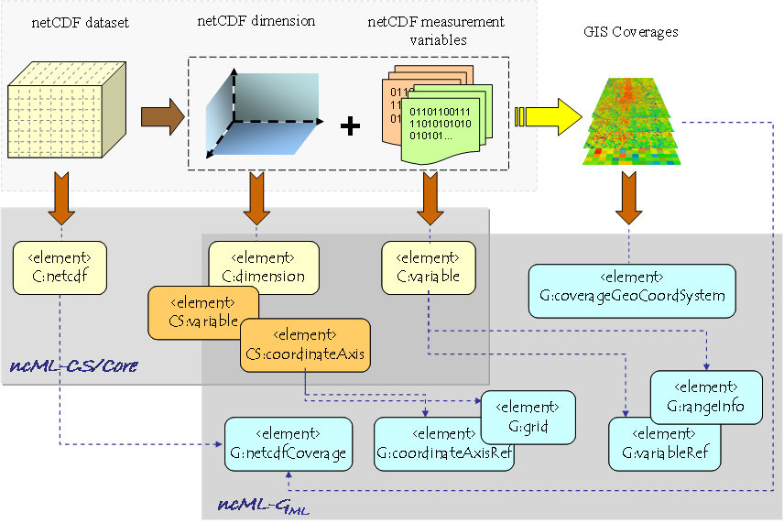
NetCDF concepts and ncML elements dependency

NcML-G_{ML} SCHEMA DOCUMENTATION
See the separete documentation

NcML-G_{ML} utilization scenarios
NcML-G and its implementation ncML-G_{ML} are extremely useful to implement a data model mediation service. Such service is essential to achieve interoperability between Earth Sciences and GIS Communities. The following picture depicts such scenario.

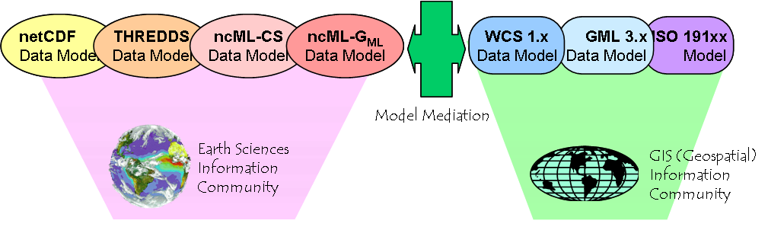
Model Mediation scenario

Interoperability scenarios
Model Mediation task is important to enable useful interoperability use cases. Some of them, based on the extension of the OGC Web Coverage Service (WCS) are briefly described.
Use Case #1
To access a netCDF dataset through WCS-THREDDS server; to serve the dataset as netCDF file
- A WCS client accesses a WCS-THREDDS server issuing a getCapability request
    - The WCS-THREDDS server accesses a THREDDS server and issues a getDatasetInventoryCatalogue request
    - The THREDDS returns a DatasetInventoryCatalogue document -extended to support the ncML-G data model
    - The WCS-THREDDS server returns an Capabilities document -extended to support the ncML-G data model
- The WCS client accesses the WCS-THREDDS server issuing a describeCoverage request
    - The WCS-THREDDS server returns a CoverageDescription document -extended to support the ncML-G data model
- The WCS client accesses the WCS-THREDDS server issuing a getCoverage request, asking for the following output format: netCDF
    - The WCS-THREDDS server returns the requested Coverage as a netCDF file.
Use Case #2
To access a netCDF dataset through WCS-THREDDS server; to serve the dataset as netCDF/OpenDAP data
- ….see the Use case #1
- ….see the Use case #1
- The WCS client accesses the WCS-THREDDS server issuing a getCoverage request, asking for the following output format: netCDF
    - The WCS-THREDDS server returns the requested Coverage as a OpenDAP pointer to a netCDF dataset
Use Case #3
To access a netCDF dataset through WCS-THREDDS server; to serve the dataset as ncML-G_{ML} document
- ….see the Use case #1
- ….see the Use case #1
- The WCS client accesses the WCS-THREDDS server issuing a getCoverage request, asking for the following output format: ncML-G_{ML}
    - The WCS-THREDDS server returns the requested Coverage as a ncML-G_{ML} document.
Use Case #4
To access a netCDF dataset through WCS-THREDDS server; to serve the dataset as GeoTIFF file
- ….see the Use case #1
- ….see the Use case #1
- The WCS client accesses the WCS-THREDDS server issuing a getCoverage request, asking for the following output format: GeoTIFF
    - The WCS-THREDDS server returns the requested Coverage as a GeoTIFF file.

The following picture depicts the architecture of the use cases scenario.

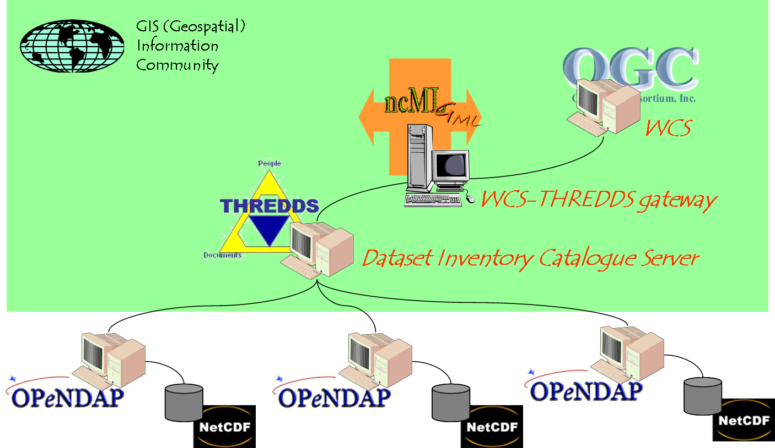

Use cases scenario architecture

Use cases Motivation
As far as these use cases are concerned, the main motivations to use ncML-G_{ML} are:
- a netCDF dataset can originate several Coverages; ncML-G_{ML} contains both the entire dataset and the set of meaningful Coverages generated to be published and dispatched to GIS applications;
- ncML-G_{ML} schema explicitly formalizes the adopted solution to harmonize ES and GIS data models; indeed, ncML-G_{ML} consists of two parts (or views):
  - a multidimesional array model for ES community realm;
  - a feature/coverage model for GIS community realm;
- there exists a difference between ES and GIS data models; thanks to ncML-G_{ML}, ES community may utilize WCS to transfer ES datasets -which are not (GIS) Coverages.

Terms and Definitions
The following terms and definitions are mainly taken from ISO TC211.
coordinate
one of an ordered set of N numbers designating the position of a point in N-dimensional space
NOTE In a coordinate reference system, the numbers must be qualified by units.
coordinate dimension
number of measurements or ordinates needed to describe a position in a coordinate system.
Coordinate Reference System
coordinate system which is related to the real world by a datum
NOTE For geodetic and vertical datum, it will be related to the Earth.
coordinate system
set of (mathematical) rules for specifying how coordinates are to be assigned to points.
geodetic coordinate system
coordinate system in which position is specified by geodetic latitude, geodetic longitude and (in the three-dimensional case) ellipsoidal height.
projected coordinate system
two-dimensional Cartesian coordinate system resulting from a map projection.
spatial reference
description of position in the real world
NOTE This may take the form of a label, code or set of coordinates.
coverage
feature that takes a coverage function as the type for a value of an attribute.
NOTE: Examples include a raster image, polygon overlay, or digital elevation matrix. Practically, a coverage is a dataset of attribute values associated to position within a bounded space.
coverage function
function that has a spatial-temporal domain and a set of values as its range.
direct positions
Position described by a single set of coordinates within a coordinate reference system.
geometry object
Spatial object representing a set of direct positions
grid
network composed of two or more sets of curves in which the members of each set intersect the members of the other sets in a regular way.
range of a coverage
set of values associated with the elements of the spatial-temporal domain of the coverage
NOTE: a spatial domain element is a NcML:dimension, and therefore its range is the domain set of values.

References
- Caron. J., “NetCDF Java Library”, Unidata netCDF packages, available at http://www.unidata.ucar.edu/packages/netcdf-java/
- ISO 19107, “Geographic information — Spatial schema”, Reference number ISO 19107:2003(E), 2003.
- ISO/DIS 19108, “Geographic information — Temporal schema”, document N1001, 12 Oct 2000.
- ISO 19111, “Geographic information — Spatial Referencing by Coordinates”, Reference number ISO 19111:2003(E), 2003.
- ISO 19115, “Geographic information — Metadata” Reference number ISO 19115:2003(E), 2003.
- ISO 19115, “Extensions to ISO/TC 211 – 19115.3 Metadata to support Imagery and Gridded Data”, Document N233, 4 Aug 2000
- ISO 19123, “Schema for coverage geometry and functions”, document N1038, 18 Jan 2001
- S. Nativi, J. Caron, E. Davis and B. Domenico, “Design and implementation of netCDF Markup Language (NcML) and Its GML-based extension (NcML-GML)”, to be published on the Computers & Geosciences Journal, Elsevier Publication, for the Special Issue on the “Applications of XML in Geosciences”.
- Nativi, S., Blumenthal, B., Habermann, T., Hertzmann, D., Raskin, R., Caron, J., Domenico, B., Ho, Y., Weber, J., 2004. Differences among the data models used by the Geographic Information Systems and Atmospheric Science communities, Proceedings of American Meteorological Society – 20th Interactive Image Processing Systems Conference, Seattle (WA), Jan 2004.
- Open GIS Consortium Inc. “Abstract Specification - Topic6: The Coverage Type and its Subtypes ver. 4”, Document 99-106, 31 Mar 1999.
- Open GIS Consortium Inc. “Web Coverage Service (WCS), Version 1.0.0”, Document OGC 03-065r6, Aug 2003.
- Open GIS Consortium Inc. “Web Map Service Implementation Specification ver. 1.1.1”, Document OGC 01-068r3, 11 Jul 2002.
- Open GIS Consortium Inc. “OpenGIS® Geography Markup Language (GML) Implementation Specification version 3.0”, Document OGC 02 023r4, 29 Jan 2003.
- Unidata netCDF Group, “netCDF Usage”, Unidata software: netCDF, available at http://my.unidata.ucar.edu/content/software/netcdf/usage.html
- Unidata netCDF Group, “NetCDF Frequently asked questions”, Unidata software: netCDF, http://available at http://my.unidata.ucar.edu/content/software/netcdf/faq.html#whatisit
- NcML Specification Group, “NcML Overview”, Unidata NcML tutorial, available at www.unidata.ucar.edu/packages/netcdf/ncml/
- Unidata netCDF Group, “NetCDF Description Language”, Unidata software: netCDF, available at http://www.unidata.ucar.edu/packages/netcdf/guidec/guidec-15.html#HEADING15-0
- Unidata netCDF Group, “netCDF Conventions”, netCDF User's Guide, available at http://www.unidata.ucar.edu/packages/netcdf/conventions.html

